6A^{th} Grade: Unit 3, Lesson 2

- Which numbers are 4 units away from the plotted point on the number line?
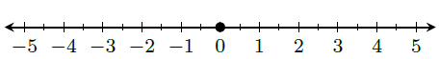

4 and -4

- What number is plotted on the number line?
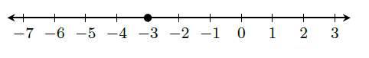
-3

- Order the numbers for least to greatest.
-2, 0, -5, 3

-5, -2, 0, 3

